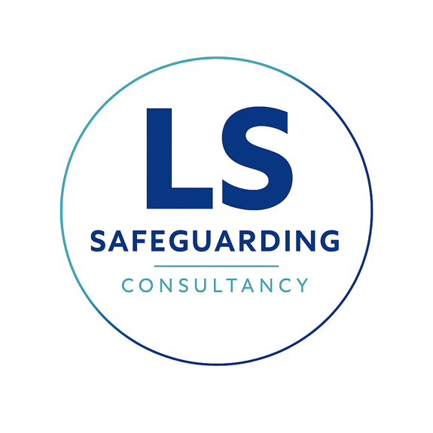
Terms and Conditions
Definitions
Lisa Shaw Consultancy Ltd is committed to maintaining high professional standards. Our team are qualified and experienced safeguarding professionals who are required to participate in reflective supervision, attend regular training, forums and network events to ensure continuous professional development and remain up to date with the latest research, statutory requirements and good practice.
Lisa Shaw Consultancy Ltd is committed to safeguarding children and all employees are subject to satisfactory background and vetting checks. These checks are in line with statutory requirements and good practice promoted by the Safer Recruitment Consortium. This includes an enhanced DBS with a Children’s Barred List.
Lisa Shaw Consultancy Ltd has both professional indemnity and public liability insurance. The company registration number is 17350206 and registered with the ICO.
Customer
The customer refers to the person or organisation that has purchased training or services from Lisa Shaw Consultancy Ltd.

Terms and conditions
Lisa Shaw Consultancy Ltd will:
- Uphold safer working practices and follow the customer’s child protection policy and procedures including the whistle blowing policy alongside Lisa Shaw Consultancy Ltd policies.
- Maintain confidentiality within a safeguarding context and in line with national guidance.
- Lisa Shaw Consultancy Ltd will liaise with the customer to agree the date, time and venue for services commissioned.
- Advise the customer at the earliest opportunity of any absence, in such cases, Lisa Shaw Consultancy Ltd will work with the customer to agree the best course of action, this may include the offer of alternative dates or an alternative trainer/consultant.
- Information retained by Lisa Shaw Consultancy Ltd will be agreed with the customer and done so in line with GDPR and the Data Protection Act 2018.
The customer will:
- Where services are delivered on site, have responsibility for ensuring that Lisa Shaw Consultancy Ltd is fully aware of all site safety requirements and relevant school/organisation procedures.
- Provide information relevant to the work undertaken.
- Where services are delivered on site, provide a suitable physical space to enable service delivery and an appropriate level of access to customer resources such as whiteboard with audio or equivalent, flip chart, photocopier etc.
- The customer will liaise with Lisa Shaw Consultancy Ltd to agree the date, time and venue for services commissioned.
- Provide payment on receipt of the invoice and in line with the terms set out.

Cancellations
Delegate training places
More than 30 days
Delegates may transfer free of charge to any other equivalent price or cheaper course. Cancellations will be fully refunded.

30 days - Two weeks
Delegates may transfer free of charge to any other equivalent price or cheaper course. 50% of the course fee will be chargeable for cancellations.
Less than two weeks
Delegates may transfer to any other equivalent price or cheaper course, £45+VAT transfer fee will apply. 100% of the course fee will be chargeable for all transfers and cancellations.
Substitution of a delegate may be made at any time at no extra cost.
In house training courses, consultancy, audits, and direct work
- Whilst every effort will be made by Lisa Shaw Consultancy Ltd to fulfil the agreement by offering alternative dates, sessions cancelled or not confirmed by the customer, will still be payable.
- The cancellation period of 30 days is required and will start from the date the written notice is received by Lisa Shaw Consultancy Ltd. Annual agreements require at least one full term’s notice.
- Sessions cancelled within less than 30 days - two weeks, 50% of charges applicable and less than two weeks 100% charges applicable.
- Sessions transferred to later date by customer within less than two weeks, 50% transfer charge will apply.

