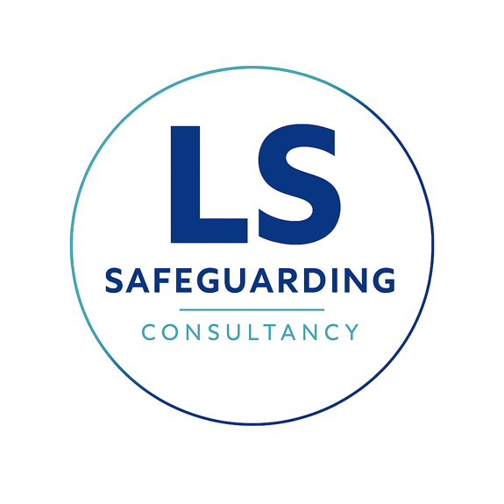
Safeguarding and Child Protection Policy

Policy Statement
Lisa Shaw Consultancy Ltd is fully committed to safeguarding and promoting the welfare of children and young people. I recognise my personal and professional responsibility to ensure that all consultancy and training services provided to educational settings adhere to safeguarding best practice at all times.
I operate in strict accordance with the following statutory safeguarding guidance:
- Keeping Children Safe in Education (KCSIE).
- Working Together to Safeguard Children.
- Guidance issued by the Disclosure and Barring Service (DBS).
I expect all partner organisations and clients to share this commitment to safeguarding and promoting the welfare of children.

Scope of Policy
This policy applies to the Director of Lisa Shaw Consultancy Ltd. As a sole trader, this document outlines the safeguarding responsibilities and professional expectations placed upon me when working with schools, academies, colleges, and other educational settings.

Designated Safeguarding Lead (DSL)
The Director is the appointed Designated Safeguarding Lead (DSL) responsible for safeguarding oversight within the business.
- Name: Lisa Shaw
- Safeguarding Training: BA Hons (SW)
- Responsibilities include:
  - Ensuring safeguarding procedures are implemented and followed during all engagements.
  - Acting as the primary safeguarding contact for schools and partner organisations.
  - Maintaining up-to-date knowledge of safeguarding legislation and providing guidance where concerns arise.
  - Ensuring all personal vetting and compliance records remain current and valid.
  - Reviewing this policy annually to ensure compliance with the latest legislation and best practice.

Vetting and Compliance Standards
To ensure I am suitable to work with children and young people, I maintain a comprehensive record of the following vetting checks, which are available to clients upon request:
- Identity Verification: Official identification documents are maintained to verify my identity.
- Right to Work: Documentation confirming my legal right to work in the UK is kept on file.
- Enhanced DBS Check: I hold a valid Enhanced DBS certificate.
- DBS Update Service Monitoring: My certificate is registered with the DBS Update Service. Status checks are conducted at least every three months to ensure ongoing compliance.
- Qualification Verification: All relevant professional and safeguarding qualifications are verified.

Professional Conduct and Boundaries
When working in any educational capacity, I commit to the following standards of professional conduct:
- Following Local Policies: I will strictly adhere to the safeguarding and child protection policy of the specific school or setting in which I am working.
- Maintaining Boundaries: I will maintain appropriate professional boundaries with students at all times.
- Online Safety: I will not communicate with students through personal social media accounts, share personal contact information with students, or engage in private messaging outside of official school systems.

Reporting Safeguarding Concerns
If I become aware of a safeguarding concern involving a child or young person during the course of my work, I will:
- Immediately report the concern to the client school’s Designated Safeguarding Lead (DSL).
- Ensure the concern is recorded according to the school's internal procedures.
- Support the school and relevant safeguarding authorities fully should an investigation be required.
All safeguarding concerns will be taken seriously and reported without delay.

Allegations Against the Director
In the event of an allegation made against me:
- I will cooperate fully with the client organisation's internal safeguarding procedures.
- I will withdraw from the placement or engagement while an investigation takes place, if required.
- Where appropriate, matters may be referred to the Local Authority Designated Officer (LADO) and the Disclosure and Barring Service (DBS).

Prevent Duty and Radicalisation
I recognise my responsibilities under the Prevent Duty to protect children and young people from radicalisation and extremism. I remain vigilant for signs of radicalisation and will report any such concerns in accordance with the school's safeguarding procedures.

Training and Awareness
I am committed to ensuring that safeguarding awareness is embedded in my consultancy. I will:
- Maintain my Social Work England registration.
- Stay informed of updates to KCSIE 2026 and other statutory guidance.
- Ensure all training materials I deliver to clients are compliant with current safeguarding legislation.
This policy was last reviewed on: 24th July 2026
Signed: Lisa Shaw

