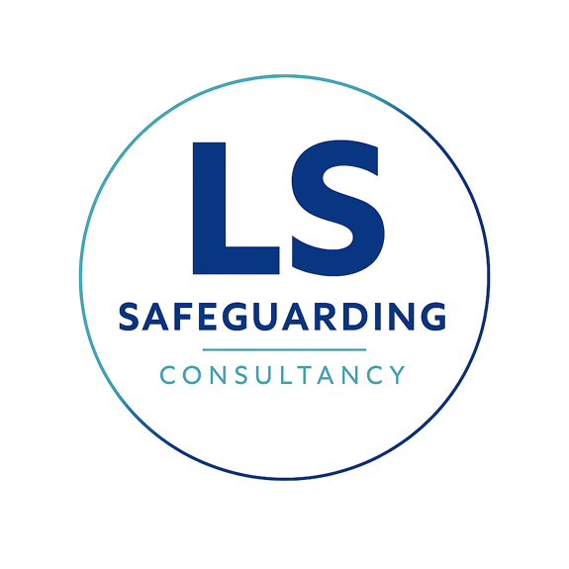
Complaints Policy

Purpose and Scope
The aim of this policy is to provide a clear framework for clients, training participants, and partner organisations to raise concerns regarding the services provided.
Critical Boundary: This policy is for service-related complaints. Direct allegations of active abuse or immediate safeguarding risks to children or adults must not follow this protocol. Such alerts must be routed immediately to statutory safeguarding leads or the police.

How to Raise a Complaint
We encourage a multi-stage approach to resolving issues:
- Informal Stage: For minor issues or initial concerns, please contact the Director via phone or email. Most concerns can be resolved quickly at this stage.
- Formal Stage: If the informal route does not reach a satisfactory resolution, or if the matter is severe, a formal written complaint should be submitted via email to the Director.
- Alternative Contact: If the complaint directly involves the Director, complainants should contact The Department for Education (DfE), Ofsted or The Local Authority Designated Officer (LADO)

Investigation Process and Timelines
We are committed to a timely and thorough investigation of every formal complaint:
- Acknowledgment: We will confirm receipt of any formal complaint in writing within 3 working days.
- Investigation: The Director or designated investigator will review all relevant notes, interview the parties involved, and assess the actions taken. This process will be completed within 28 days.
- Resolution: Upon completion of the investigation, the complainant will receive a formal written outcome. This report will detail any organisational changes, improvements to training protocols, or lessons learned as a result of the complaint.

Commitment to Improvement
Lisa Shaw Consultancy Ltd views complaints as an opportunity for professional growth. Every formal resolution is used to assess our internal practices to ensure the highest standards of advice and training for the education and care sectors.
This policy was last reviewed on: 24th July 2026
Signed: Lisa Shaw

