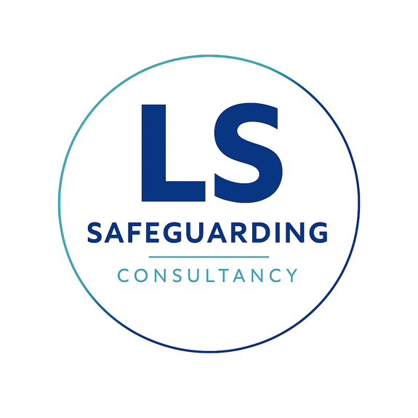
Whistleblowing Policy

Introduction
We all may experience concerns about something happening at work at some point. When a concern feels serious—such as potential fraud, danger, or safeguarding malpractice, including providing negligent advice to schools or failing to report a known child protection risk—it can be difficult to know how to act.
We understand you may feel worried about the repercussions of raising a concern, feeling it may be disloyal to colleagues or our consultancy. However, the leadership of Lisa Shaw Consultancy Ltd is committed to running this organisation with the highest integrity, and we need your help to ensure the safety of the children and institutions we serve. This policy is designed to reassure you that speaking up is safe, welcome, and will enable us to act quickly. You do not need proof before speaking to us; we encourage you to raise the matter as soon as you have a concern.

Who is this policy for?
This policy applies to all who work for or with Lisa Shaw Consultancy Ltd, including full-time and part-time staff, independent safeguarding consultants, and volunteers.
This policy is intended for concerns where the public interest is affected, such as:
- Failure to follow statutory safeguarding guidance (e.g., Keeping Children Safe in Education).
- Providing incorrect or dangerous advice to a school or college regarding a child protection matter.
- Concealing or failing to report a safeguarding concern identified during an audit or training session.
- Breaches of the law or risks to health and safety.

Our assurances to you
We are committed to honesty and integrity and expect all staff to maintain high standards. If you raise a genuine concern, it does not matter if you are mistaken; you will not be at risk of losing your job or suffering any form of reprisal. We will not tolerate the harassment or victimisation of anyone raising a genuine concern and will treat such actions as a disciplinary matter.
We hope you will raise concerns openly, but you may speak to someone confidentially if you prefer. We will take steps to protect your identity and will not disclose it without your consent unless required by law, particularly in matters of child safeguarding.

How to raise a concern internally
You do not need to provide detailed evidence, but please explain the circumstances of your concern as fully as possible.
- Step one: If you have a concern about malpractice, please raise it first with your manager or team leader, either orally or in writing.
- Step two: If the matter remains unresolved or is so serious that you cannot discuss it with the above, contact: Lisa Shaw at lisashawconsultancy@gmail.com

How we will handle the matter
We will acknowledge receipt of your concern within two working days. We will assess the matter and determine the appropriate action, which may involve an internal inquiry or formal investigation. We will inform you who is handling the matter and, if requested, provide a summary of your concern and a timetable for updates.
Whenever possible, we will provide feedback on the outcome of the investigation, though we may be limited by duties of confidence owed to others. While we cannot guarantee a specific outcome, we strive to handle every matter fairly.

Victimisation
We are grateful to those who come forward and will not tolerate any attempt to silence or victimise whistleblowers. Examples of victimisation include bullying, disciplinary action, or attempts to identify an anonymous whistleblower. If you experience any reprisal, alert the person you originally raised the concern with or use the formal grievance procedure.

Raising a matter externally
While we hope you feel empowered to raise concerns internally, you may report a concern to an outside body if necessary. We would rather you raise a matter with a regulator than not at all. Relevant external bodies for our sector include:
- The Department for Education (DfE)
- Ofsted
- The Local Authority Designated Officer (LADO)

Monitoring and Data Protection
The Director is responsible for this policy and will review it annually to reflect legal and sector developments. We will keep a confidential record of your concern in accordance with data protection legislation.

Independent advice
If you are unsure whether to use this policy, you can contact the independent charity Protect at 020 3117 2520 for free, confidential legal advice. Protect’s advisers can explain your rights and the best way to raise your concern. You may also contact your professional body for advice.
This policy was last reviewed on: 24th July 2026
Signed: Lisa Shaw

