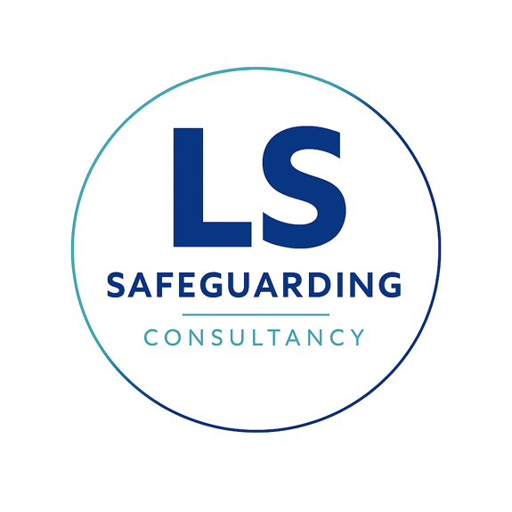

Safeguarding Policy Statement
Purpose and Scope
The primary aim of Lisa Shaw Consultancy Ltd is to provide high-quality safeguarding advice, consultation, and safeguarding training. The purpose of this policy statement is to protect children and young people who receive our services from harm, including the children of adults who engage with our consultancy. This policy provides our staff, volunteers, and clients with the overarching principles that guide our approach to child protection.
Legal Framework
This policy is drawn up on the basis of legislation, policy, and guidance that seeks to protect children in the relevant nation of operation (England, Northern Ireland, Scotland, or Wales).
Core Beliefs
We believe that:
- Children and young people should never experience abuse of any kind.
- We have a responsibility to promote the welfare of all children and young people, to keep them safe, and to practice in a way that protects them.
We Recognise That:
- The welfare of children is paramount in all the work we do and in all the decisions we take.
- Working in partnership with children, young people, their parents, carers, and other agencies is essential in promoting welfare.
- All children, regardless of age, disability, gender reassignment, race, religion or belief, sex, or sexual orientation, have an equal right to protection from all types of harm or abuse.
- Some children are additionally vulnerable due to previous experiences, level of dependency, or communication needs, and may require extra safeguards.
How We Will Seek to Keep Children Safe
We will maintain a safe environment by:
- Valuing, listening to, and respecting children and young people.
- Appointing a nominated child protection lead
- Adopting safeguarding best practices through our internal policies, procedures, and a code of conduct for all staff and volunteers.
- Providing effective management through supervision, support, and training so that all personnel follow policies and behaviour codes confidently.
- Implementing safer recruitment processes, ensuring all necessary checks are made when selecting staff and volunteers.
- Recording, storing, and using information professionally and securely, in line with data protection legislation.
- Sharing information about safeguarding and good practice with children and their families.
- Using our procedures to manage allegations against staff and to share concerns with relevant agencies appropriately.
- Ensuring effective complaints and whistleblowing measures are in place.
- Building a safeguarding culture where everyone treats each other with respect and feels comfortable sharing concerns.
Supporting Documents
This policy statement should be read alongside our other organisational documents, including:
- Code of conduct
- Complaints Procedure
- Privacy Policy
- Whistleblowing Policy.
Contact Details
- Nominated child protection lead: Lisa Shaw
- NSPCC Helpline: 0808 800 5000
Review and Commitment
We are committed to reviewing our policy and good practice annually.
This policy was last reviewed on: 24th July 2026
Signed: Lisa Shaw

